EMERGENCY DRONE FLEET AND MISSION MANAGEMENT SYSTEM
Industry-Based Case Study
Course Code: DSA01
Course Name: Object-Oriented Programming with C++
Course Outcome: CO3 & CO4

Submitted By
Name: Veeram Prakash Reddy
Register Number:192472402
Department: Computer Science
Year: II| Year
Institution: Saveetha Institute of Medical and Technical Sciences (SIMATS)

Assignment Title
Emergency Drone Fleet and Mission Management System Using C++

Technologies Used
Programming Language: C++
Concepts: Object-Oriented Programming, Constructors, Destructors, Operator Overloading, Inheritance, Polymorphism and Pointers

PSEUDO CODE
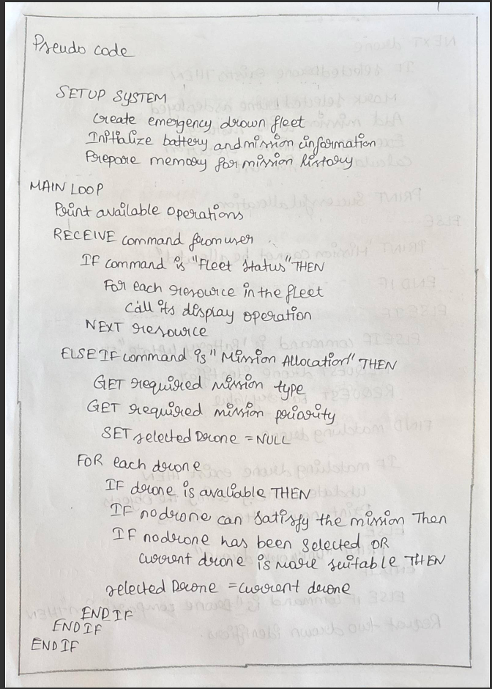

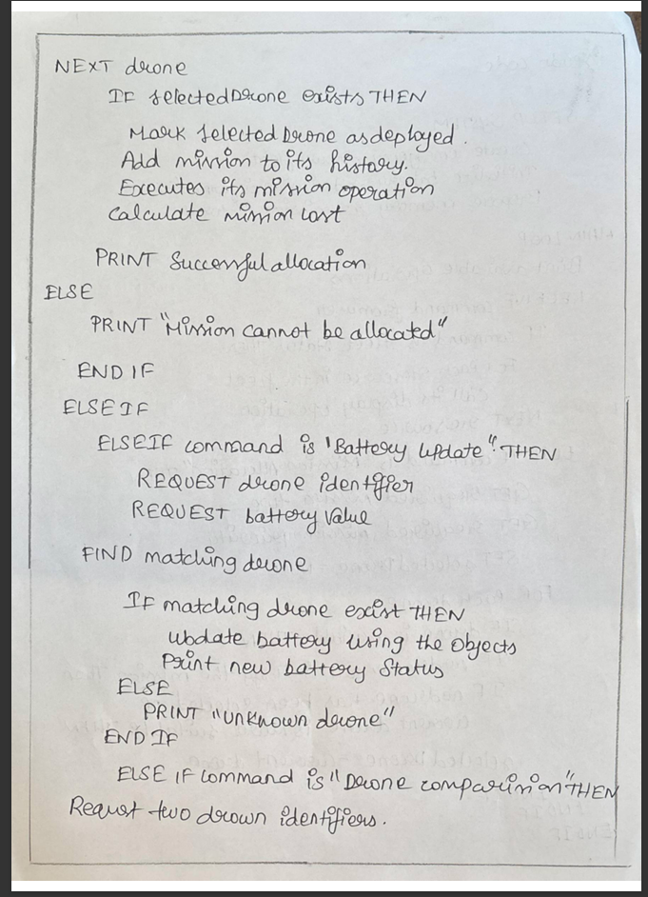

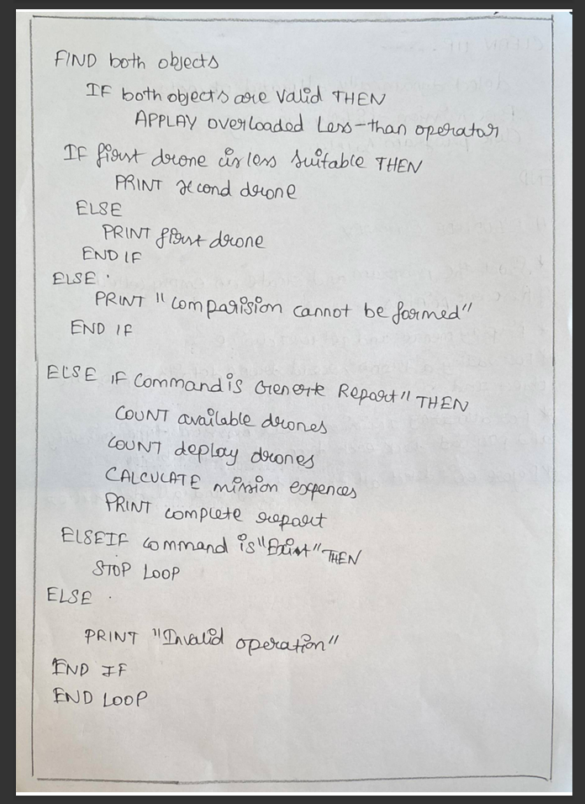
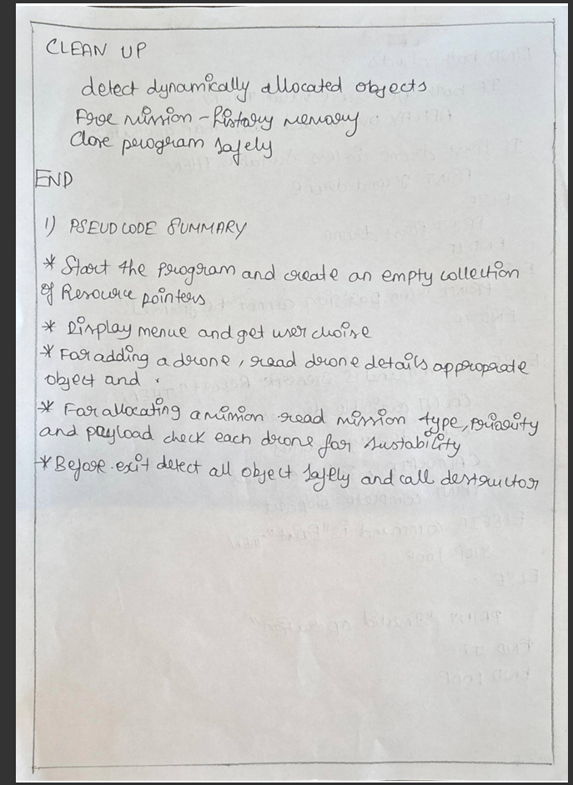
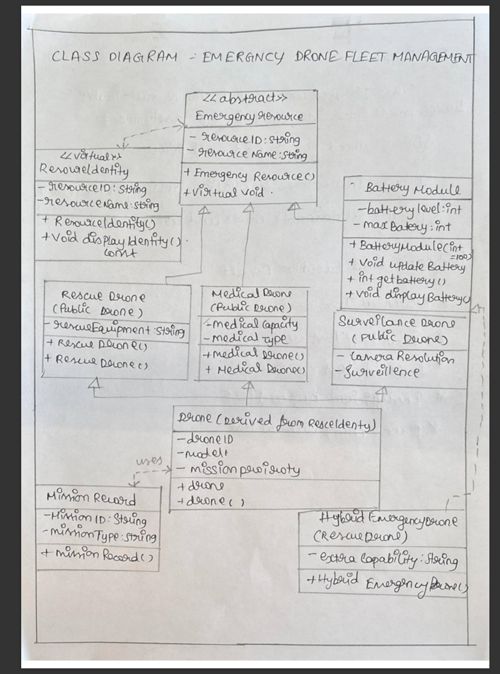
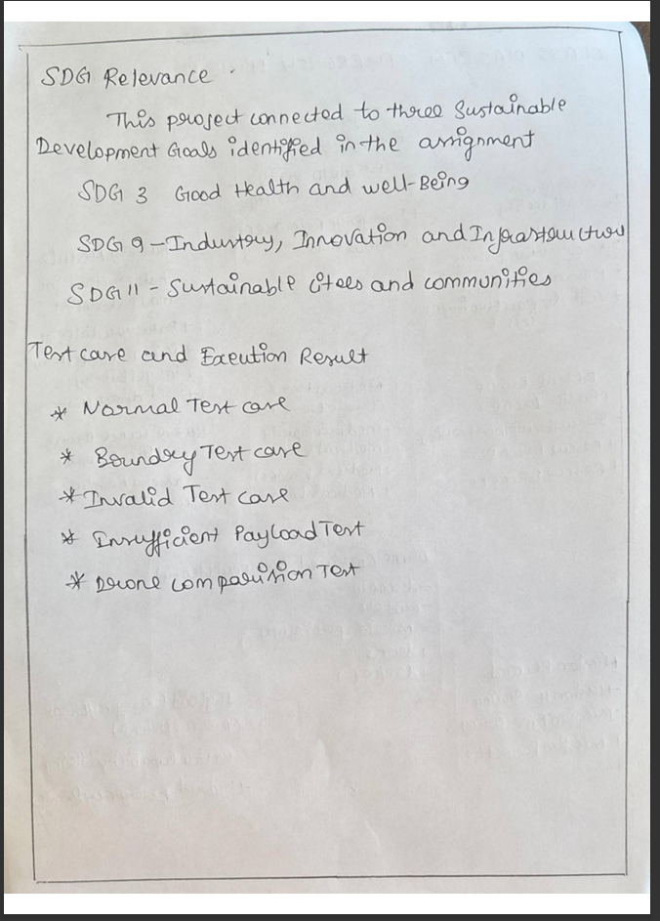
SOURSE CODE
Emergency-Drone-Fleet/
│
├── index.html
├── style.css
├── script.js
├── server.js
├── drones.json
├── missions.json
├── package.json
└── package-lock.json

The main source code is:

index.html → website structure/UI
style.css → colors, animations, responsive design
script.js → frontend functionality
server.js → Node.js/Express backend and file storage
drones.json → drone data
missions.json → mission data

Your package.json contains:

{
"name": "emergency-drone-fleet",
"version": "1.0.0",
"description": "",
"main": "script.js",
"scripts": {
"test": "echo \"Error: no test specified\" && exit 1",
"start": "node server.js"
},
"keywords": [],
"author": "",
"license": "ISC",
"type": "commonjs",
"dependencies": {
"express": "^5.1.0"
}
}
To run the project

Open PowerShell inside the project folder:

npm start

Then open:

http://localhost:3000

One important point: for your college submission, don't submit only the website files. Your assignment specifically asks for the C++ source code, including OOP concepts such as constructors, deep copy, dynamic allocation/destructor, operator overloading, abstract classes, inheritance, virtual base class, member class, heterogeneous pointers, this pointer, and safe derived pointers.

So your website is the frontend/demo, while we should also prepare the C++ source code corresponding to the assignment requirements. That is the next thing I'd recommend preparing for submission. THIS IS MY SOUSE CODE GIVE ME AS I WANT TO PASTE IN WOERD

EXECUTION RESULTS
The Emergency Drone Fleet and Mission Management System was tested to verify the correct functioning of drone management, mission allocation, battery updates, drone comparison and reporting features. The testing includes normal, boundary and invalid test cases, as required by the assignment.
3.1 Normal Test Case
In the normal test case, valid drone and mission details are entered into the system. The system checks the available drone's battery level, payload capacity, operating range and deployment status. If all conditions are satisfied, the suitable drone is selected and the mission is successfully allocated.
Input:
- Valid Drone ID
- Valid Drone Type
- Battery Level: 90%
- Payload Capacity: 20 kg
- Operating Range: 50 km
- Valid Mission Type
- High Mission Priority
Expected Result:
- Drone is identified as available.
- Mission requirements are checked.
- Suitable drone is selected.
- Mission is successfully allocated.
- Drone status is updated.
- Mission information is recorded.

Output:
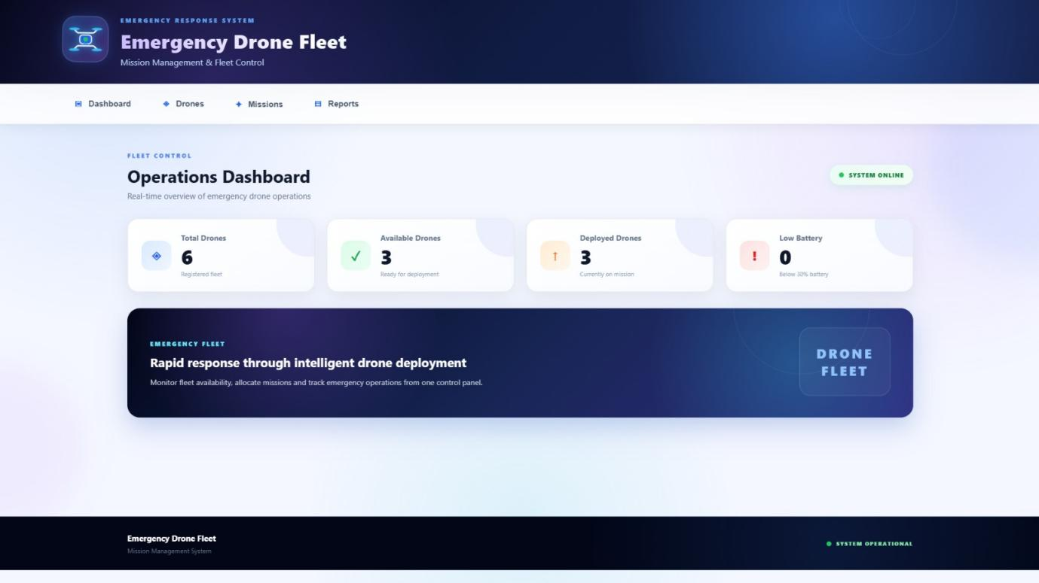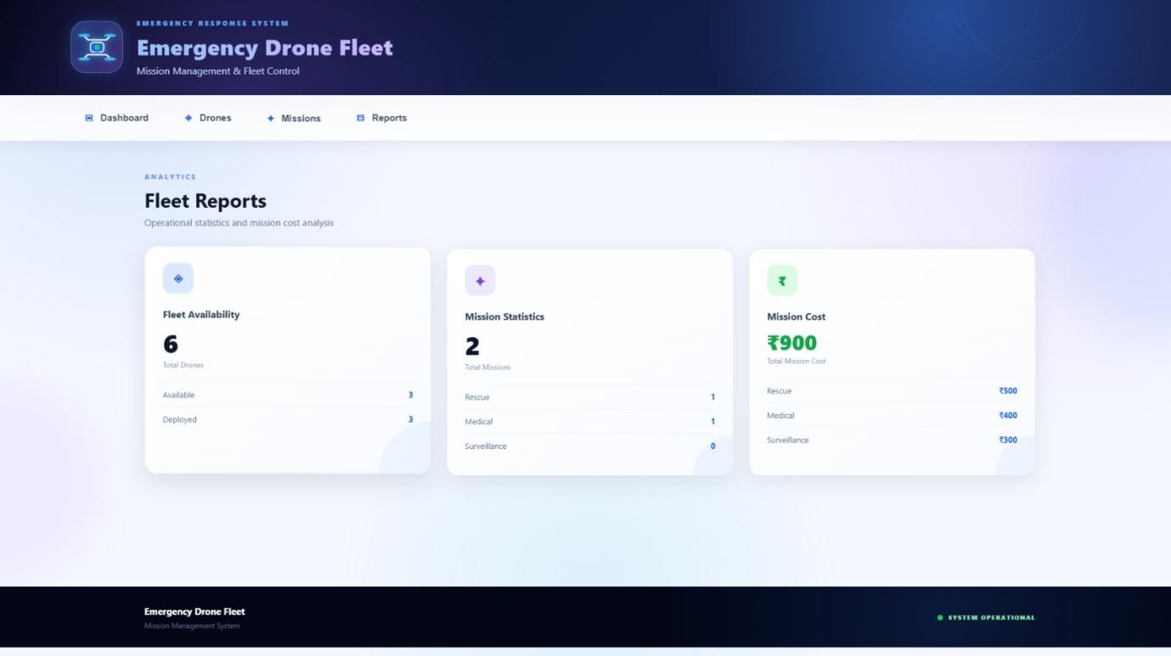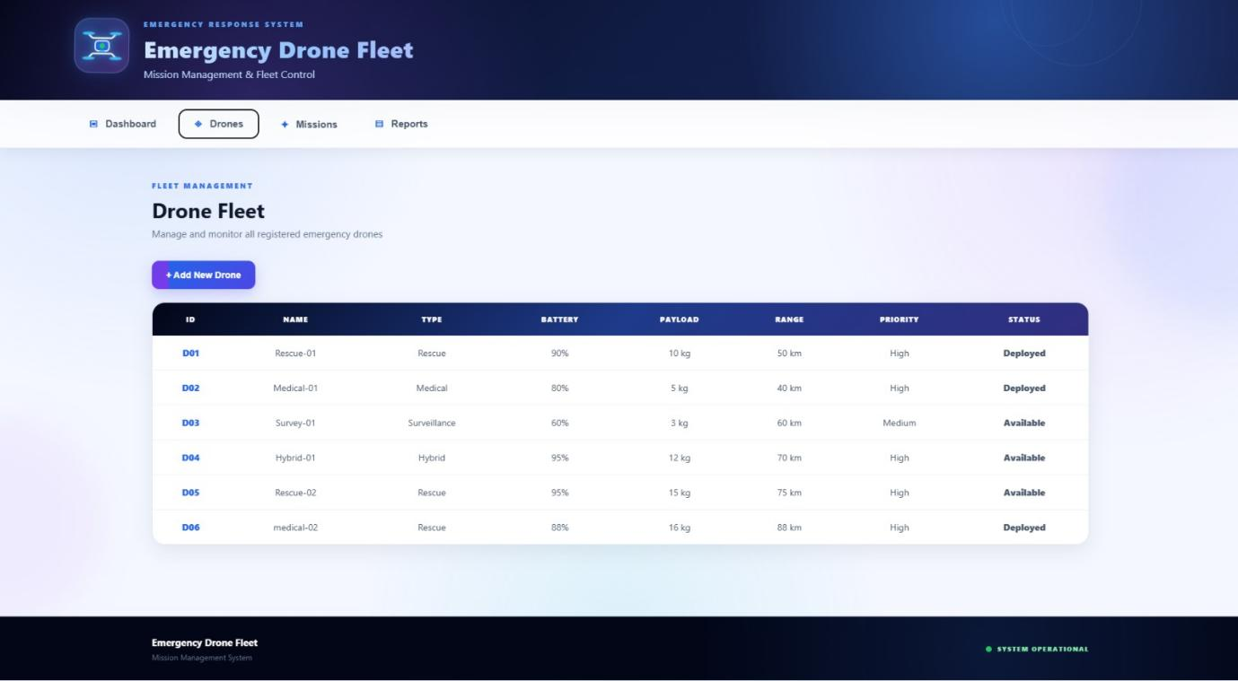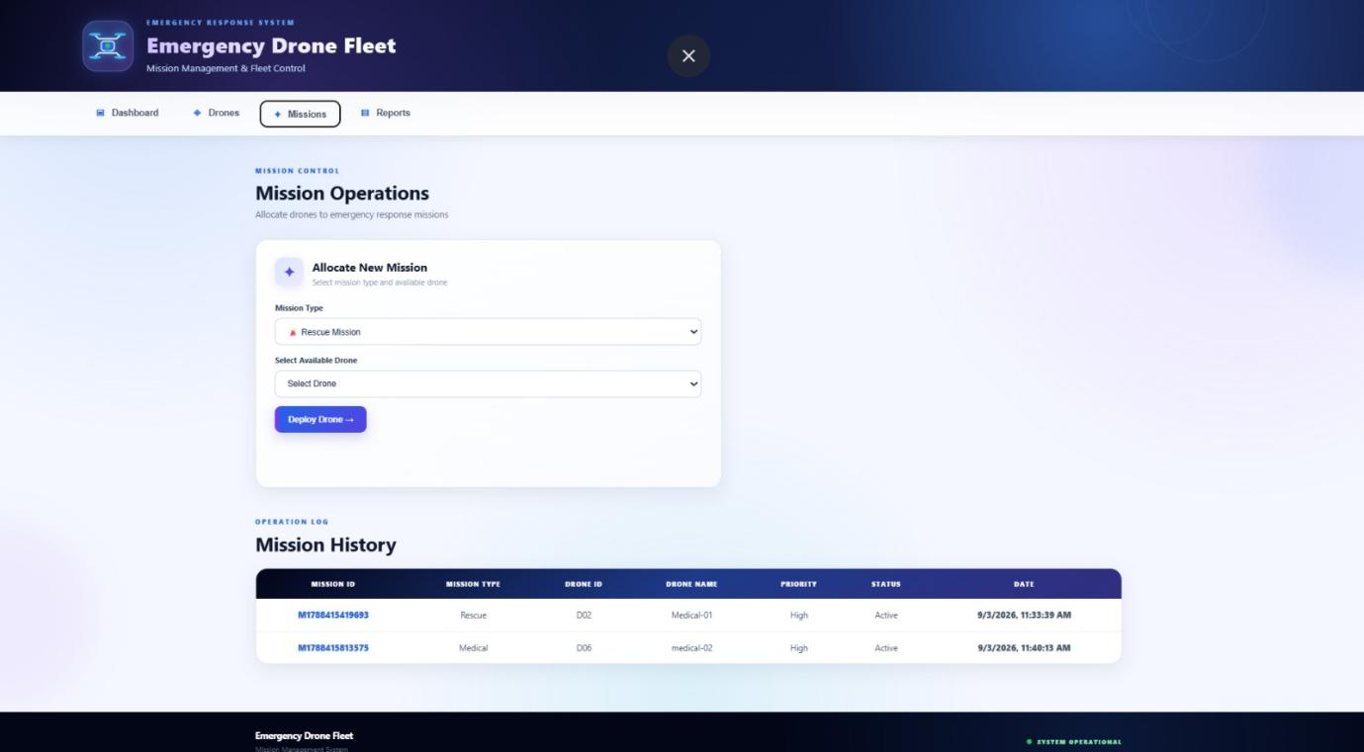

4. SHORT REFLECTION
4.1 Design Choices
The Emergency Drone Fleet and Mission Management System was designed to manage different types of drones and allocate them to suitable emergency missions. The system maintains important information such as drone identity, battery level, payload capacity, operating range, mission priority and deployment status.
The application follows an organized structure where different components are responsible for different functions. The web interface provides an easy way for the user to interact with the system, while the backend manages drone and mission data. This separation makes the system easier to understand, maintain and extend.
The project also demonstrates the use of Object-Oriented Programming concepts required for the assignment, including constructors, destructors, operator overloading, inheritance, polymorphism and pointers.
4.2 Memory Safety
Memory management is an important consideration in the implementation of the C++ version of the system. Dynamically allocated mission-history data must be released properly when it is no longer required.
The copy constructor should perform deep copying so that copied drone objects have their own independent mission-history memory. The destructor should release all dynamically allocated resources safely.
Proper memory management helps prevent:
- Memory leaks
- Double deletion
- Dangling pointers
- Invalid memory access
- Unexpected program crashes
The assignment specifically evaluates whether dynamically allocated resources are safely released without leaks, double deletion or dangling pointers.
4.3 Inheritance and Pointer Usage
Inheritance is used to represent different types of emergency drones. The abstract EmergencyResource class provides a common interface, while specialized drone classes can implement their own mission operations.
The project demonstrates:
- Abstract classes
- Pure virtual functions
- Hierarchical inheritance
- Multilevel inheritance
- Virtual base classes
- Multiple inheritance
- Base-class pointers
- Derived-class pointers
- Runtime polymorphism
- The this pointer
Base-class pointers allow different types of drone objects to be managed through a common collection. Virtual functions ensure that the appropriate derived-class operation is executed at runtime.
The assignment requires safe use of base pointers, derived pointers, virtual dispatch and the this pointer while avoiding unsafe casting and lifetime errors.
4.4 SDG Relevance
The Emergency Drone Fleet and Mission Management System is related to the following Sustainable Development Goals.
SDG 3 – Good Health and Well-Being
- Medical drones can support emergency medical-delivery operations.
- Rescue drones can assist during emergency situations.
- Faster allocation of suitable drones can support timely emergency response.
SDG 9 – Industry, Innovation and Infrastructure
- The project applies software technology to emergency drone management.
- Automated fleet management demonstrates an innovative approach to emergency operations.
- The system provides an organized infrastructure for managing different drone resources.
SDG 11 – Sustainable Cities and Communities
- Drone-based emergency response can support disaster-management activities.
- Surveillance drones can assist in monitoring affected areas.
- Organized mission allocation can contribute to safer and more responsive communities.
The assignment explicitly maps the project to SDG 3, SDG 9 and SDG 11.
4.5 Learning Outcome
This project provided practical experience in applying programming concepts to an industry-based emergency-management problem. It helped develop an understanding of how different drone resources can be organized and allocated according to mission requirements.
The project also provided experience with constructors, destructors, operator overloading, inheritance, polymorphism, pointers and memory management. Testing the application using normal, boundary and invalid cases helped improve understanding of input validation and functional correctness.
Overall, the project demonstrates how software design and object-oriented programming can be applied to create an organized emergency drone management system.

